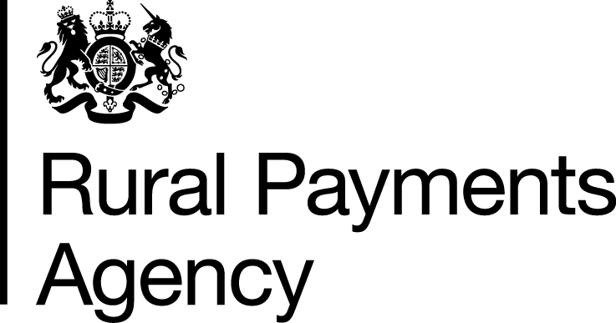 | Rural Payments Agency  PO Box 352  Worksop  S80 9FG |  | T: 03000 200 301  E:ruralpayments@defra.gov.uk  Twitter: @Ruralpay  www.gov.uk/rpa
<Customer Name>
<Address>

<Date>
SBI: <SBI>
Trader number/Vendor number: <Vendor Number>
Business name: <Business Name>
Our ref: MsD Bank let (7.0)

Dear <Customer Name>

We have updated your bank details

You contacted us recently to update the bank account details for the above business.

We have now updated the bank account details with the information you provided. The full information is not included here for security reasons but the last four digits of your new bank account number are <4 Digits>.

We have sent this letter to all members of the business who have ‘full’ or ‘make legal changes’ permission.

If you have any questions about this letter
If you have any questions or if you need to make any changes in the future, please call us on 03000 200 301. Please tell us your SBI number which you can find at the top of this letter. We can only discuss your personal and business information if you have permissions for the business and can answer our security questions.

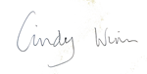
Yours sincerely/faithfully

Cindy Winn
Head of Customer Engagement

